**Q1. Install MLflow**

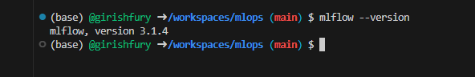

**Q2. Download and preprocess the data - Answer = 4**

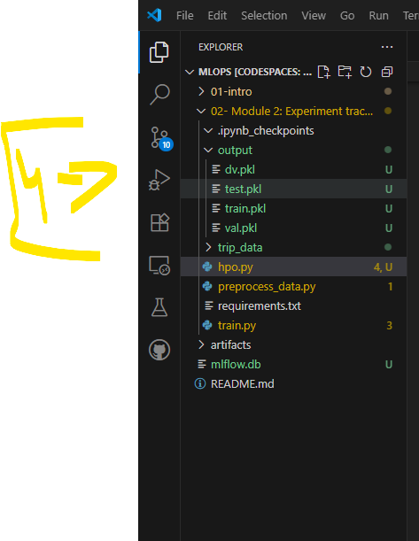

**Q3. Train a model with autolog : Script is available in github – Answer = 2**

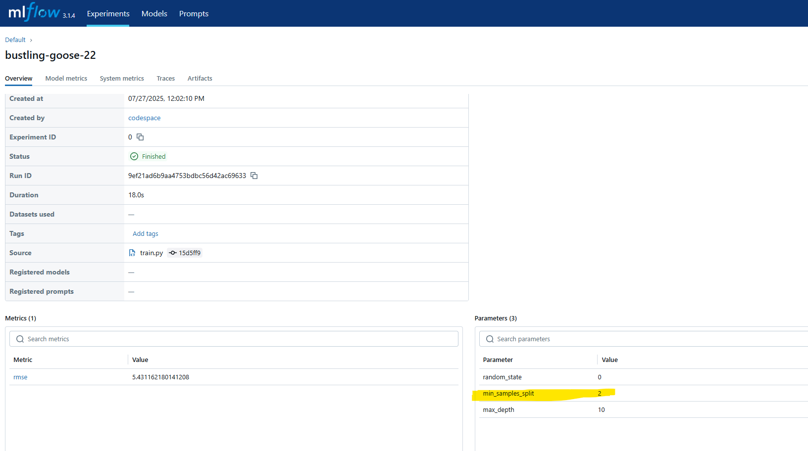

**Q4. Launch the tracking server locally**

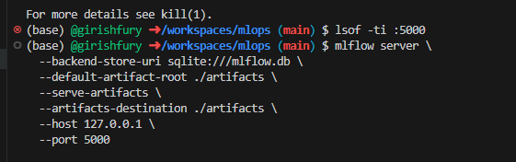

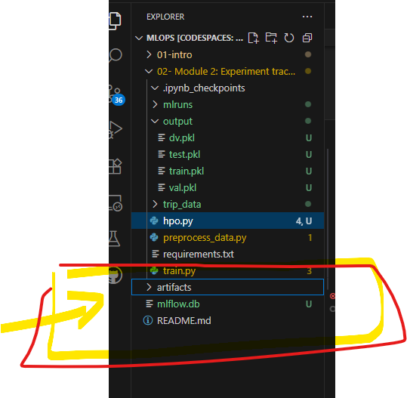

**Q5. Tune model hyperparameters – Answer =5.335**

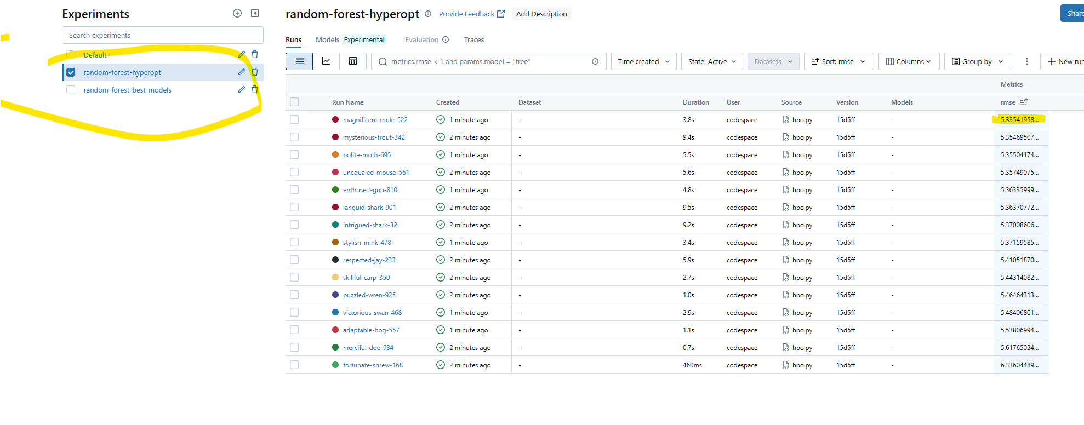

* **Q6. Promote the best model to the model registry : 5.567 test RMSE**



